March 2018
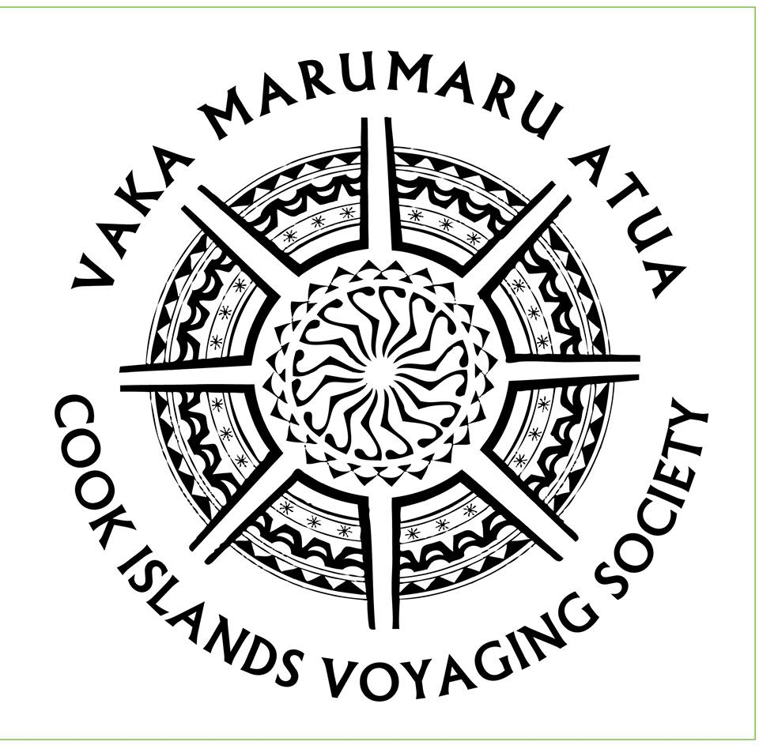

Kia Orana, the Cook Islands Voyaging Society would like to wish you all a Happy and Prosperous New Year.
As you all know 2017 was a challenging year with the devastating fire on board Marumaru Atua in September which has been extensively damaged as a result. In November last year we had a visit from Robin Williams, a Maritime New Zealand Recognised Surveyor of ships and AMSA accredited surveyor. His recommendation is that although there was a possibility to repair the vaka, it is not his recommended course of action for a number of reasons which shared in his report. Based on his assessment our target to fundraise has been set to $320,000 which includes building a brand new hull and replacing the areas and equipment damaged by the fire.
On Friday 2/2/18 Minister of Finance Mark Brown announced that Government had pledged $255,000 for the replacement of the damaged hull of the Marumaru Atua. Cabinet has approved a request by the Voyaging Society to have the hull rebuilt in New Zealand. Minister Mark Brown said in his announcement that Marumaru Atua is an icon of the Cook Islands. And that Government believed that this case was similar to that of the two schools that were subject to arson. The hull will be rebuilt in New Zealand by Salthouse Boat Builders. Each hull is constructed of e-glass and foam using advanced infusion processes. In contrast to these modern methods, tradition remains clearly visible with each hull lashed together using wooden beams and ropes. CIVS is grateful for the support of the Government in recognising the importance of restoring this National Treasure.
In the meantime, the Cook lslands Voyaging Society continues in its fundraising efforts to raise the balance of the funds needed.
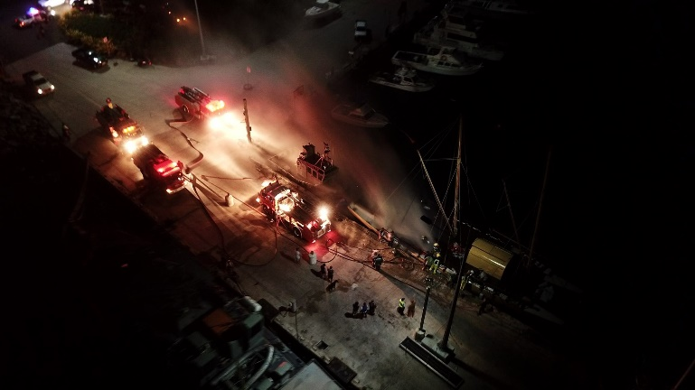
Firefighters at the scene of the fire, photo credit Varo Media.
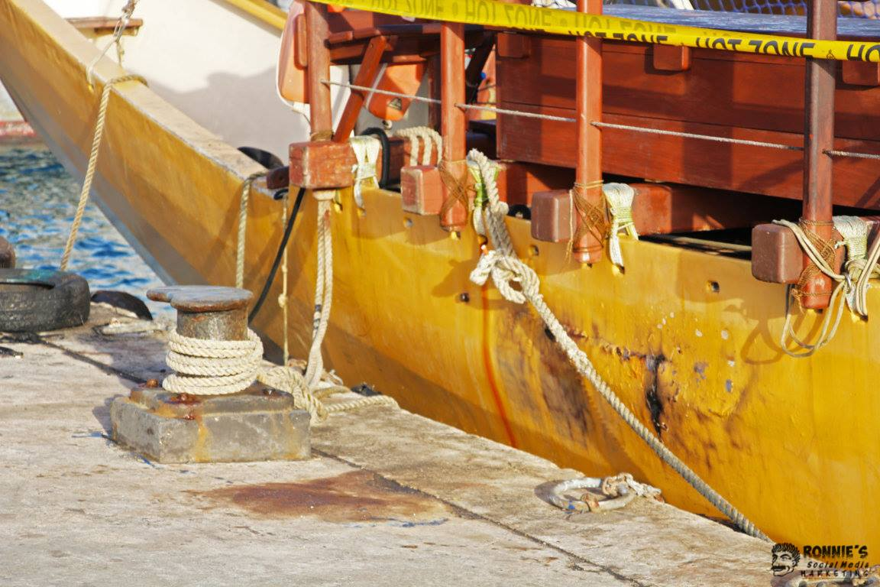
In February CIVS received a donation of $20,000 from David & Sarah Gordon who read about the fire on the TIS newsletter. David and Sarah Gordon have shown lifelong commitment to bird conservation and provided ongoing support and assistance to Birdlife Pacific Partners. Together they established the Birdlife International Community Conservation Fund, which has contributed directly to recovery operations for threatened bird species.

The Gordon’s said that the “Voyaging Society is a wonderful concept, conserving the traditions of the Cook Islands people and, most importantly, passing on to the next generation both the skills and the gift of their inheritance. We think this is so important in a world where traditional values are being lost [to the detriment of mankind]. It is also a bonus for the natural environment in that these traditions bring people closer to nature so that they feel an affinity and a need to conserve. And having come to know Ian Karika, we know that the Society is led by an outstanding man whose values are the real values of the natural world.
So when we heard of the fire, we felt that it was of the greatest importance that the Vaka be repaired. We hope that this gift will help and also encourage others”.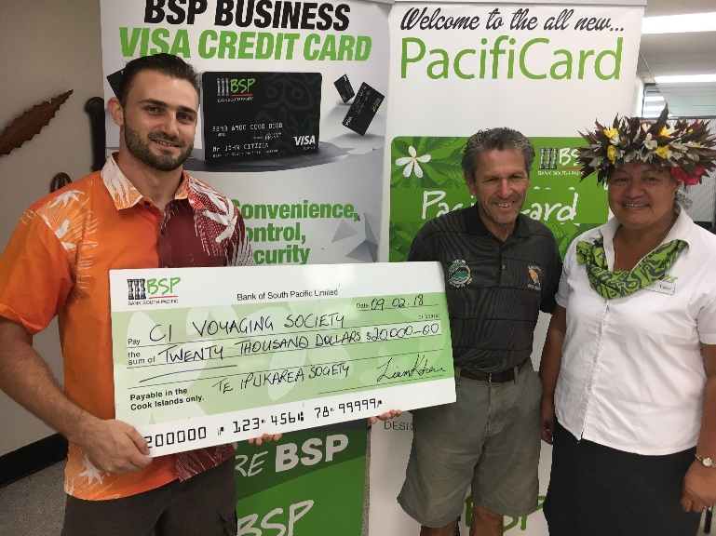
President Ian Karika receiving the donation from TIS Representative Liam Kokaua.
The NZ High Commission to the Cook Islands has also pledged $10,000 to go towards the replacement of the safety equipment on the vaka.

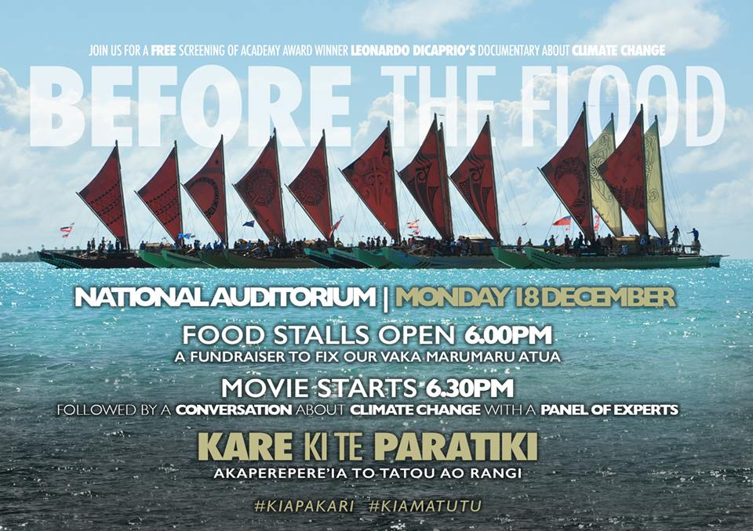
Climate Change Cook Islands held a free screening of Academy Award Winner Leonardo DiCaprio's Documentary about Climate Change, Before the Flood at the National Auditorium on the 18th of December. The film features Leonardo DiCaprio on a journey as a United Nations Messenger of Peace, traveling to five continents and the Arctic to witness climate change firsthand. The screening was followed by a Conversation about Climate Change with a Panel of Experts. It was also an opportunity to raise funds on the night to fix our Vaka Marumaru Atua with just over $2,500 raised on the on the night.
Meitaki maata to the Office of the Prime Minister, Cook Islands Marine Park - Marae Moana, Rongohiva LED for organising this event.
A very special Meitaki Maata to Leonardo DiCaprio Foundation and National Geographic for supporting this screening of the film.
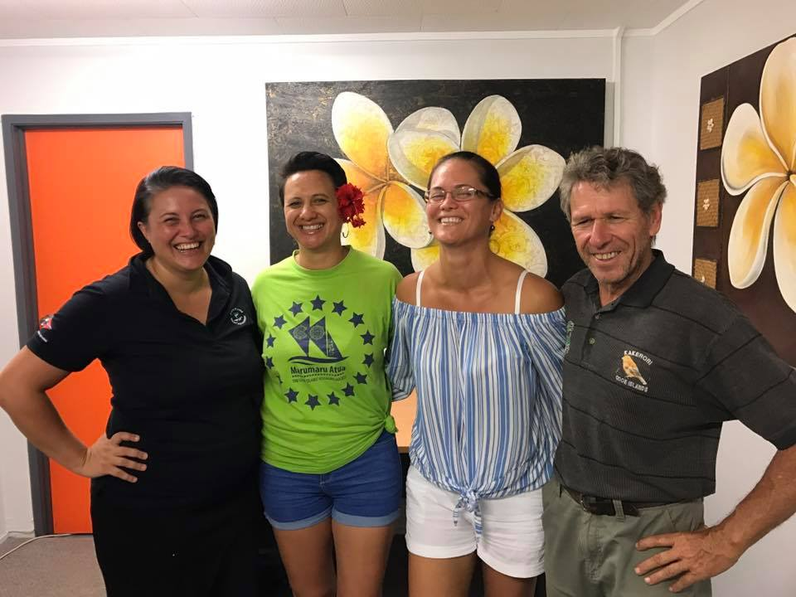
Cook Islands Women in Maritime Association generously supported the Cook Islands Voyaging Society with a quiz night fundraiser. They handed over a $800.00 cheque to our President Ian Karika. In partnership with CIWiMA, we always want to encourage more women voyagers to join our crew.
With all this generous support it makes our target easier to raise! You can support by sponsoring a fundraiser or donating directly.
Every bit helps towards getting our vaka back in the water!

Cook Islands Voyaging Society Website
Our new website is currently under construction. We would like to say meitaki maata to Bryon Brown for offering his services to set up a new website.
We will advise when the website it live. The website will be linked to our Facebook page https://www.facebook.com/MarumaruAtua/ and Instagram Page civs_marumaru_atua.
Marumaru Atua Reusable Coffee Cups
What if you were told that despite all your eco-friendly efforts, the recyclable disposable cup you get with your morning coffee still ended up in landfill? This is the case for almost all disposable cups in the Cook Islands.

This love affair with coffee and the daily takeaway is somewhat of a ritual but sadly, takeaway cups are a real concern for the environment. Everyday tens of THOUSANDS of takeaway cups are thrown in the rubbish, ending up in landfill. One takeaway coffee a day creates 10 kilos of waste each year - that's a whole tree worth of paper!
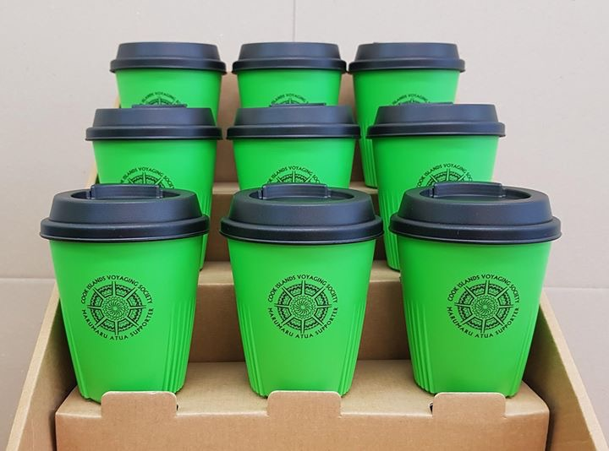
You can make a difference and help reduce your waste, by making a pledge to use only a reusable coffee (or tea) cup today. The Cook Islands Voyaging Society is currently selling reusable coffee cups for $20.00 as a fundraising initiative and as a way to encourage consumers that they are part of the solution to the growing waste problem.
Rakeimata Tangata Tu’ua O Samuela Koronui (Ninja)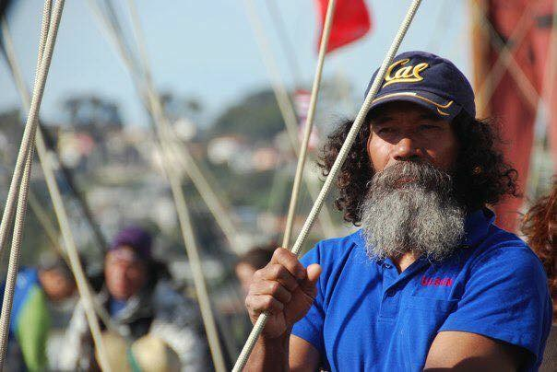
Koro in San Diego
It was with great sadness we learned of the passing of our dear friend, crew member and navigator Ninja after a short illness on the 14th of February 2018 in Atiu. Ninja sailed on Te Au O Tonga on many occasions, Hokulea, and Tahiti Nui Freedom from Tahiti to China and was crew member on Marumaru Atua for the Te Mana O Te Moana Voyage 2010-2012. Ninja will be missed by his vaka family and friends.

NZ FESTIVAL – Waka Odyssey
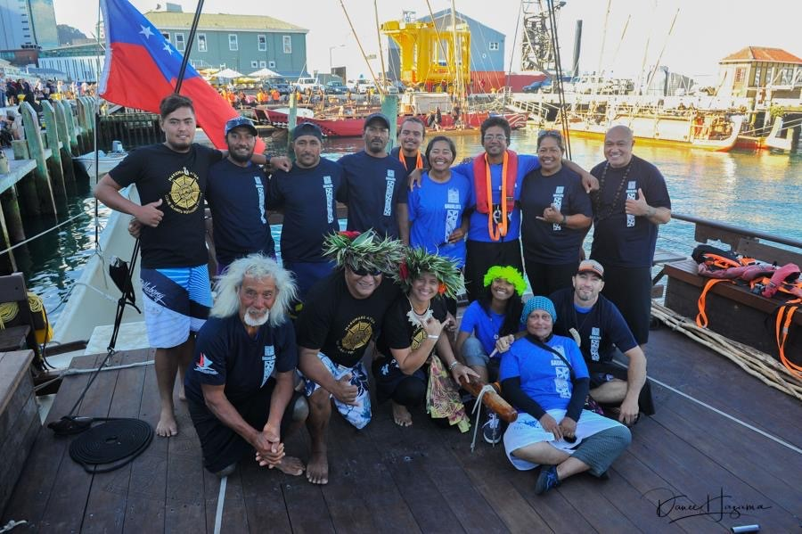
CIVS crew members on board Gaualofa PC: Danee Hazama
In February, representatives from CIVS: Ian Karika, Travel Tou from the House of Ariki, Sam Timoko, Cecile Marten, Teina Mackenzie, and Bouilard Davis travelled to Wellington to participate in the New Zealand Festival-Waka Odyssey. On 23rd February, the Opening Night extravaganza, Kupe, welcomed a fleet of waka from the Pacific, with a thousand-strong haka, mass choir, and pōwhiri. Three voyagers from CIVS (Sam Timoko, Bouillard Davis, and Teina Mackenzie) joined the Samoan va’a family aboard the Gaualofa. The next day, Saturday, February 24th, they sailed on Gaualofa from the Wellington Harbour to Petone for an Open Day for the community. Gaualofa remained up on the shore and had many eager people come aboard to learn more about life on a traditional voyaging vaka. On Sunday, representatives from the Cook Islands and Tonga attended church services in Porirua along with the President of the Cook Islands Traditional House of Ariki, Kaumaiti Tou Ariki. The rest of the days were filled with supporting and attending various sessions arranged at Te Papa Museum and various Universities in Wellington, along with school visits to the vakas at Wellington Harbour. While we would have loved to sail on Marumaru Atua, we thank our vaka brothers and sisters aboard the Gaualofa who welcomed us. The Waka Odyssey opening night drew the largest number of spectators EVER to an event in Wellington!
Social Impact Fund
Meitaki Ma’ata to the Social Impact Fund for supporting our educational work with the support of $30,000 a year over the next three years. With Sam Timoko as our educational co-ordinator, we will reach out to classrooms to provide educational talks and connect more students with our voyaging history.
Check out the UNESCO Canoe is the People curriculum here: http://www.canoeisthepeople.org/about.php. We plan to strengthen our educational and environmental outreach making Marumaru Atua “a floating classroom” at sea. If you would like your school to participate please contact Sam Timoko on 55772. Marumaru Atua is for our next generation of tamariki.
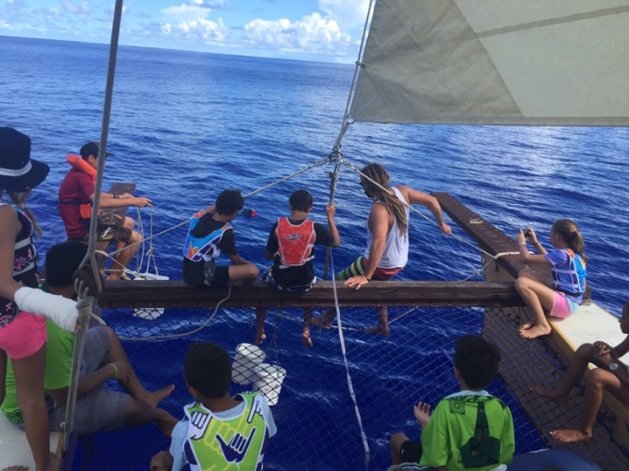
Working Bees
Need a fun Saturday cultural activity? Come to our and join our working bees! We have much sanding and prepping to do before and after MMA repairs. We are looking for as many hands as possible, and for some power tools. Please call Sam Timoko 55772 or Alex Olah 71473. We really value any help you can provide with the working bees and promise that your contribution of time will be mutually beneficial – caring for our vaka will enrich you in cultural discovery.
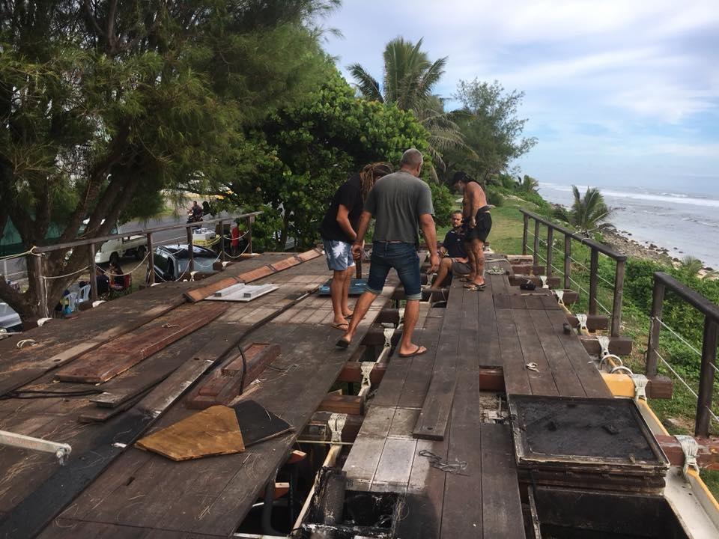
Bio-Fuel Engine
As part of the refit, Salthouse Builders, and in consultation with our senior experience captains it has been recommended that we use this opportunity to switch from a solar powered engine to a bio-fuel engine. The solar-powered engine has been difficult to maintain and replacement of the parts are prohibitively expensive. The Biofuel engine offers reliability, economy, environment-friendly, user-friendly, accessible parts, and above all safety. While we mostly sail, we also need a source of propulsion for tricky situations. Safety of the crew and canoe must come first! We continue to merge modern science with traditional knowledge.
Bio-fuel engines have been successfully used by Okeanos Foundation on their vaka motu operating in the Pacific. This are normal diesel engines that run on coconut oil/bio fuel. Over the past few years, in Vanuatu, about 200 buses were using a coconut oil/diesel mix on a daily basis. Vanuatu is the 15th largest producer of copra and coconut under different forms represent 35% of exports.
The coconut tree grows from a single seed, which is an entire coconut, taking between 6 and 10 years to bear fruit, and living between 60 and 80 years.
Fruit production increases as the tree matures, peaking at between 20-40 years of age, at which point a healthy tree will produce 50 to 200 coconuts per year, depending on a few things (medium, subspecies, care etc.).
Switching to a bio-fuel engine also can provide a opportunity for a source of income for the Northern Group to utilise their coconuts and produce the oil locally for CIVS.
We will use this refit as an opportunity to change our engines, but not our stories, not our focus, not our tradition and culture, and certainly not our values. We will update you as we get more information.
Annual General Meeting
The AGM will be held in April. Okeanos Foundation for the Sea gifted Marumaru Atua to the people of the Cook Islands in 2012 in recognition for their contribution to the Te Mana O Te Moana Voyage under the custodianship of the Cook Islands Voyaging Society. She belongs to all of us and we invite everyone to attend this important meeting. Come and share your ideas.
Read All About It
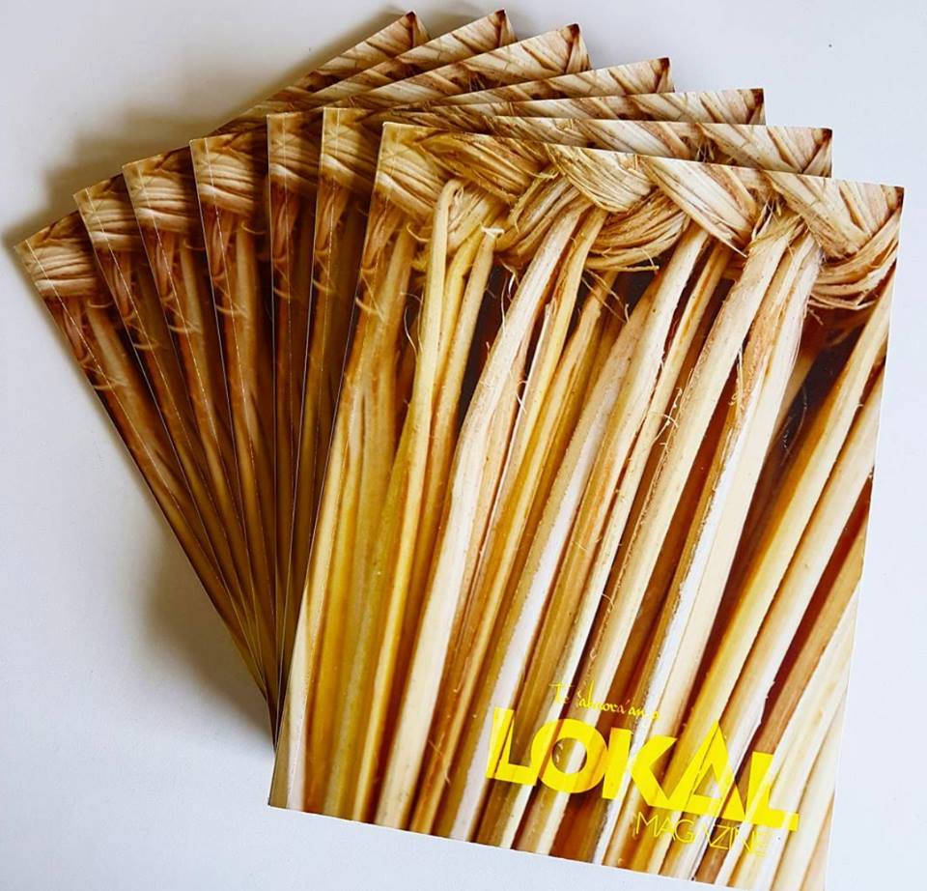
The inaugural issue of LOKAL magazine featured an interview with Captain Ti Pekepo and talked about the importance of voyaging and promoting local culture. The recent issue of ESCAPE magazine ran a feature about Marumaru Atua and her importance as a national icon. Follow us on Facebook to get regular updates, and read all our news.

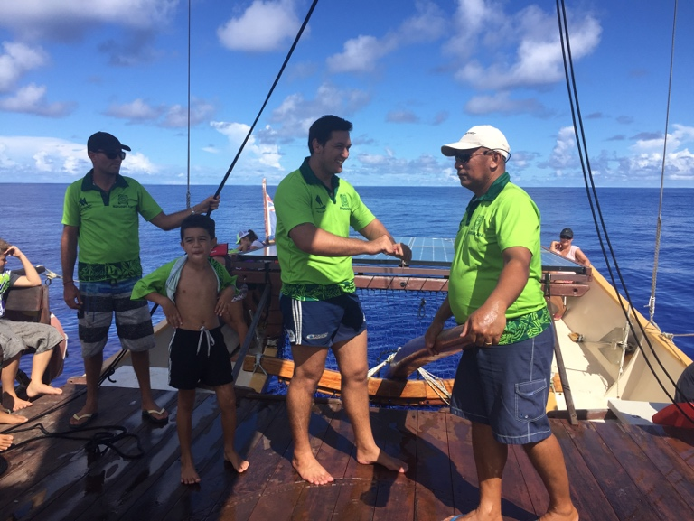
The people who make the biggest difference are the ones who do little things consistently. Make “reusing” a habit and “refuse” single use plastics.
Meitaki Ma’ata
We would like to thank the many volunteers, individual donations, and offers of support that have made the Cook Islands Voyaging Society over the years.
We want to extend a special thank you to the landowners who have allowed the vaka to be stored on their land. Meitaki Ma’ata to Robert Wichman, Albert Nicholas, Sr Elizabeth, Emona Russell Numanga, Akapi families, and all the other landowners whom we may not have mentioned by name for this generous and fantastic support.
We would also like to say meitaki maa’ta to Paul Mangakahia - Multi Contractors, Malcolm Sword, Cook Islands General Transport, Moana Sands Beachfront Hotel, Central Motel, Nick Peal, Robin Williams, Maritime Cook Islands, Brendon Smith for their assistance.

